**MY PROFILE**

To change your password and update security questions/answer, select the **My Profile** link. Depending on system configuration, the **My Profile** link may either be found by hovering over your username in the upper right-hand corner of the screen, or by directly clicking on **My Profile** in the navigation bar.

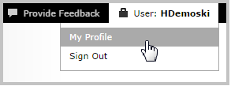 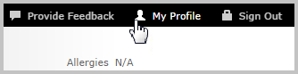

Here, you can **Change Password** or update your **Security Questions**.

